Project Design Phase

Proposed Solution Report
Project: Script-Controlled ACL – Restrict Record Access Based on Field Value
Date | 1 October 2026
Team ID | SWTID-2026-7653
Project Name | Script-Controlled ACL – Restrict Record Access Based on Field Value
Maximum Marks | 2 Marks

1. Proposed solution overview
The proposed solution is a script-controlled, operation-specific ACL design for the ServiceNow table `u_institution_details`. It evaluates the requesting user’s roles, the requested CRUD operation and—where required—the Branch value of the target record before allowing or denying access.
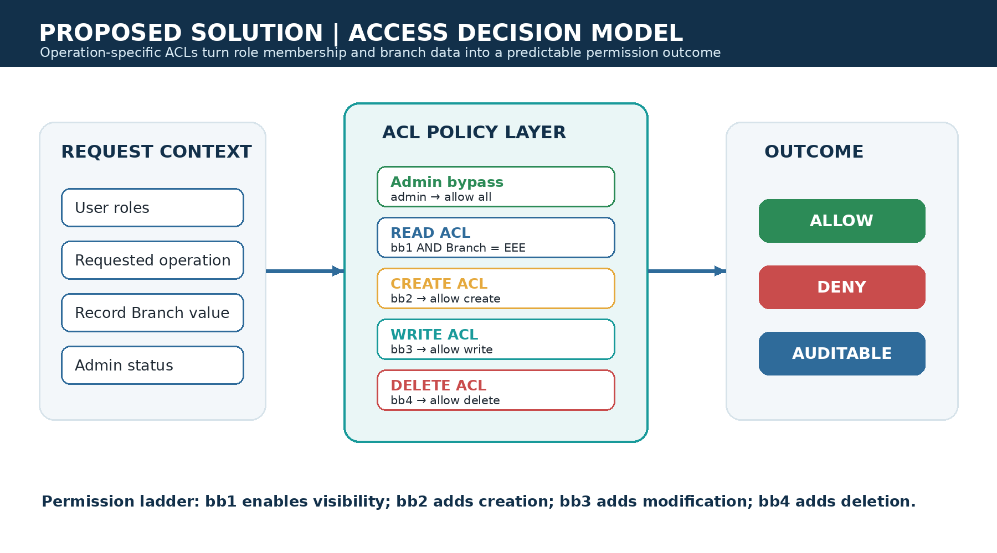
Figure 1. Custom access decision model for the proposed ServiceNow solution.

2. Template parameter response
S.No. | Parameter | Description
1 | Problem Statement (Problem to be solved) | Institution/student records require branch-level confidentiality and controlled CRUD access. A user must not gain access merely because a record is reachable through a list or form; access must be decided by roles and record data.
2 | Idea / Solution description | Create a custom `u_institution_details` table and define four record ACLs: READ with `bb1` plus Branch = EEE; CREATE with `bb2`; WRITE with `bb3`; DELETE with `bb4`. Add an administrator bypass in the advanced script and verify through impersonation.
3 | Novelty / Uniqueness | The design combines field-aware authorization with an incremental role ladder. It demonstrates how the same record can be readable, creatable, editable or deletable only as the user’s privileges progress, while keeping the branch condition close to the security decision.
4 | Social Impact / Customer Satisfaction | Reduces the likelihood of exposing student contact and academic information to unauthorized users. Clear permission boundaries improve trust for institutions and make the access policy easier to explain to staff and auditors.
5 | Business Model (Revenue Model) | The current project is an educational and governance pattern rather than a commercial product. It can be packaged as a ServiceNow implementation accelerator, security configuration service, training lab or reusable scoped-application module.
6 | Scalability of the Solution | The pattern scales by adding branches, roles, operations and tables through configuration. For production scale, role naming, inheritance, automated tests, logging, performance checks and a policy matrix should be standardized across applications.

3. Functional design
ACL | Required role | Data condition | Permitted capability
READ | bb1 | Branch is EEE | View EEE records
CREATE | bb2 | None in project design | Create records
WRITE | bb3 | None in project design | Edit records available to the user
DELETE | bb4 | None in project design | Delete records
Administrator bypass | admin | Not applicable | Full access

4. Implementation workflow
- Create the test EEE user and custom roles `bb1`, `bb2`, `bb3` and `bb4`.
- Create `u_institution_details` and add the project fields: auto-number roll number, reference fields, Branch choice (ECE, EEE, CSE), Email, Phone Number and Description.
- Create and activate record ACLs for READ, CREATE, WRITE and DELETE; elevate `security_admin` when configuring ACLs.
- For READ, apply the Branch = EEE data condition and use the advanced script to allow administrators or users with `bb1`.
- Impersonate representative users and verify list visibility, New button availability, editing and deletion behavior.

Evidence of the READ ACL script and branch condition
The project evidence shows the advanced ACL script and the Branch condition used to constrain access. This directly supports the proposed policy model.

Project evidence screenshot: Evidence of the READ ACL script and branch condition

Evidence of the READ ACL configuration
The project evidence shows the record ACL configuration, including the operation, table name and branch data condition.

Project evidence screenshot: Evidence of the READ ACL configuration

5. Acceptance criteria
ID | Acceptance criterion | Pass condition
AC-01 | Branch-level read security | A user with `bb1` can see EEE records but not ECE/CSE records.
AC-02 | Default deny | A user without the required ACL role cannot read protected records.
AC-03 | Create authorization | Only a user with `bb2` (or admin) receives create capability.
AC-04 | Write authorization | Only a user with `bb3` (or admin) can edit permitted records.
AC-05 | Delete authorization | Only a user with `bb4` (or admin) can delete permitted records.
AC-06 | Administrative support | An administrator can access records across branches for support and verification.

6. Solution assessment
The proposed solution is technically feasible within the ServiceNow ACL model and is appropriately scoped for the project. Its main strength is clarity: each operation has a named role and a testable outcome. Before production adoption, the design should add automated ATF tests, confirm whether create/write/delete also require branch conditions, document role inheritance, and verify that integrations and background scripts do not bypass the intended policy.

References
Primary source: project document “Script-Controlled ACL – Restrict Record Access Based on Field Value,” supplied by the project owner. Template structure adapted from the Phase 3 Proposed Solution Template.

